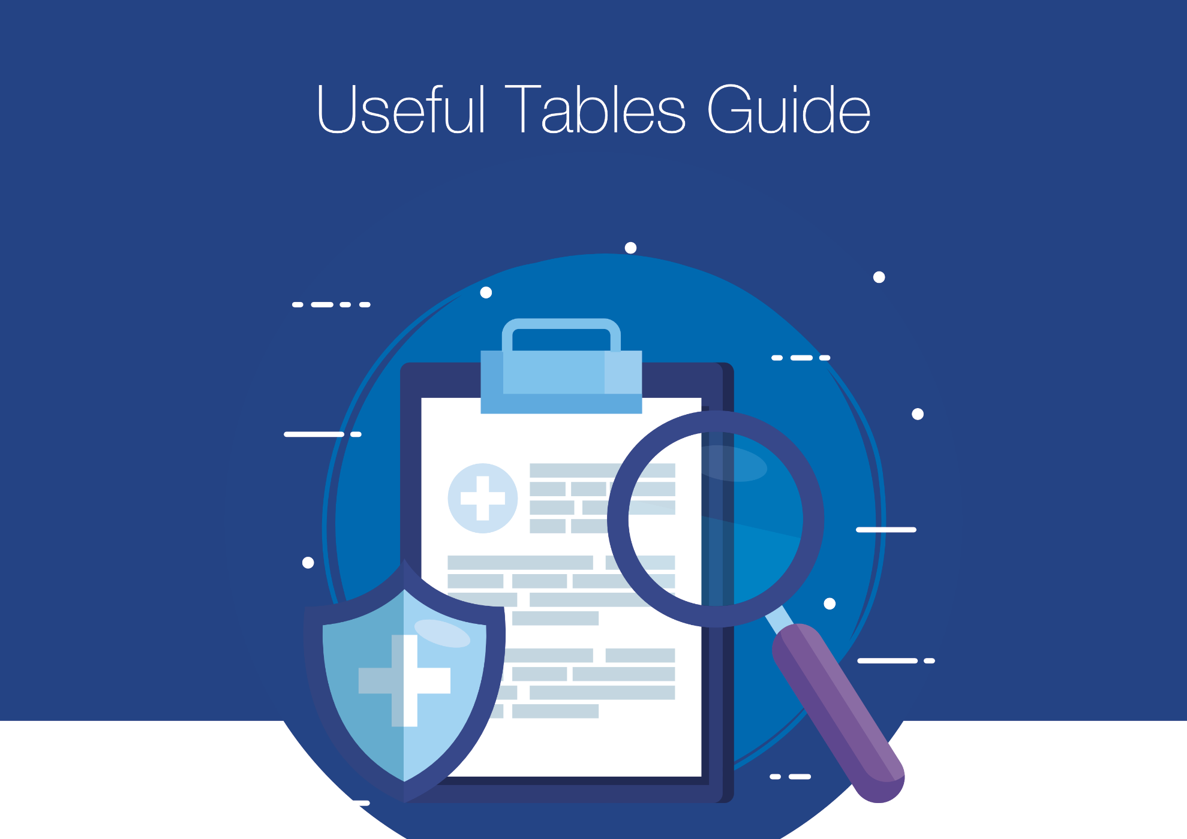

by Yvonne Coleman
Drug Name | Nutrients  Affected | % BPP | N/V | C/D | ↑↓ Weight | ↑↓ Appetite | Taste Changes | Dry Mouth | ↑↓  BSL

BPP – binding to plasma proteins, N – nausea, V – vomiting, C – constipation, D – diarrhoea, BSL – blood sugar levels

Drug Name | % BPP | ↑↓  BSL | N/V | C/D | ↑↓ Wt | ↑↓ App | ∆  Taste | Dry Mouth | Thirst | Tremor | Dysp | Drool

BPP – binding to plasma proteins, BSL – blood sugar levels, N – nausea, V – vomiting, C – constipation, D – diarrhoea, wt – weight, app – appetite, ∆ change, dysp – dysphagia

Drug Name | Na | K | Fe | Mg | Zn | Ca | B12 | Fol | B1 | B6 | D | CoQ10 | Other

Na – sodium, K – potassium, Fe – iron, Mg – magnesium, Zn – zinc, Ca – calcium, fol – folate, B1 – thiamine, B6 – pyridoxine

Diabetes drugs - duration of effect – allow time to onset and post-peak diminishing effect
Drug | Duration hrs | Break-  fast | MT | Midday | AT | Evening meal | Supper | Break-  fast

